LEAPFROG

- Project Fact Sheet -
Key Facts:
Title: Leadership for European Apparel Production From Research along Original Guidelines Acronym: LEAPFROG
Consortium: 35 partners from 11 countries
Budget: 26 Mio €, of which 14 Mio € EC funding
Project Coordinator: Euratex – The European Apparel and Textile Organisation
Expected Project Start: Q1-2005
Duration: 48 months

Project Goal:
The central goal of LEAPFROG is to achieve a technology breakthrough in the clothing industry.

Industry Problems Tackled:
Clothing production in Europe suffers from the high labour cost component involved in garment manufacture which makes this activity largely uncompetitive in high-labour cost countries. The heavy quality critical human intervention in garment made-up operations further leads to unusually high levels of faulty products – up to 20% even in well-run factories with qualified operators – unimaginable in most other industrial production processes.
Another field of potentially massive efficiency gains is the garment design and prototyping process which today remains much too time and cost intensive with its craft-like organisation, lengthy trial and error procedures and inefficient means of communications.
Another focus area will be the overall organisation of the clothing business with all its supply chain and further business partners. Inefficiencies in this area are responsible for frequent overstock as well as out-of-stock situations, for enormous missed business opportunities, idle capacity and waste problems on all stages of the supply chain. These inefficiencies are also responsible for the fact that, despite an every increasing choice of clothing products in Europe’s shops, supply hardly kept pace with growing consumer expectations and too often frustrated shoppers miss the right size in their desired colour and style, complain about poor product quality despite high prices and finally spend their money on other consumer products. Percentages of consumer spending on clothing has been in constant decline in all European countries for more than two decades.

Proposed solutions and quantifiable results:
- A step-change in productivity, quality and cost efficiency in the garment manufacturing process.
- Radical reengineering and intelligent automation of the key tasks of handling and sewing for significant reduction of labour cost component in garment manufacture and a massive quality increase
- A significant improvement of fabric preparation facilitating subsequent clothing manufacturing operation through fabric pre-forming and temporary or permanent fabric stiffening
- Overall integration and organisation of all individual processes and technologies into a highly efficient and flexible manufacturing shop floor
- A radical move towards rapid customised manufacturing in one of the most demand-volatile sectors through flexibilisation and integration of cost-effective and sustainable processes from fabric processing through to customer delivery.
- Development of concepts and tools for a flexible organisation of garment production in extended supply networks – the extended Smart Garment Organisation (xSGO)
- Methods and systems for efficient product development and fast production ramp-up and roll-out in geographically spread manufacturing networks
- A paradigm change in customer service and customer relationship management with a focus on value-adding product-services.
- Further development of concepts and tools for industrial mass customisation and made-to-order of clothing and their effective integration with the point of sale
- Development of methods and corresponding systems for direct input of user requirements and consumer preferences into product design and development to timely offer customised or personalised producs and produt-services

Quantifiable Results of LEAPFROG
- reduction of 60% of physical prototypes through 3D virtual garment design and prototyping. An average time gain of 60% in garment design by reduction of trial-error loops before acceptable prototype is reached from 5 to 2
- an average 50% decrease of time of production ramp-up of new products in geographically spread production networks
- a reduction of average lead times at the future garment factory of 25%
- a reduction of machine times of complex garments by up to 50% in case of part automation of joining and up to 80% in case of full automation
- a reduction of production errors and quality faults in garment made-up from current 15-20% to close to zero due to removal of the human error
- an average decrease of fabric stocks at textile & garment manufacturers of 35% by intelligent, real-time distributed production planning systems and direct feedback from retail partners enabled in the xSGO
- an overall reduction of garment stock levels and waste resulting from unsold items at fashion retailers by 35% through an enlargement of the mass customisation and fast fashion segment from today’s below 5% to 20% of the total market by 2015

Schematic project overview

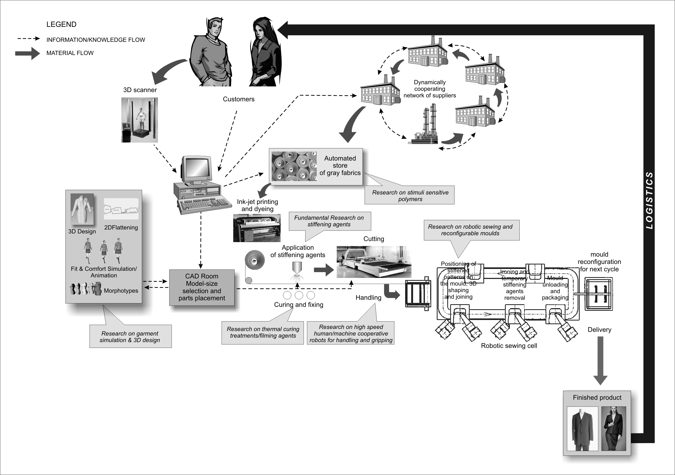

The long-term Vision:

If LEAPFROG research and development work reaches its objectives there will be enormous innovation and new business potential across the entire spectrum of textile, clothing, machinery and service companies in Europe. Overall trends for high-quality fashion or functional clothing manufacturing point towards the need for smaller, highly flexible production units with sophisticated logistics and a range of other service provision capacities close to the final point of sale or use. Clothing companies need to be prepared to develop, manufacture and distribute their products in truly collaborative dynamic business networks. Suppliers, manufacturers and service companies that are prepared to work under such a scenario are therefore the most likely to benefit most from LEAPFROG solutions.

Planned Activities:

The planned project work will be broadly divided into the following major activities:

- Development of a holistic clothing production re-engineering framework & definition of high-level specifications of technology components and interfaces to be developed (months 1 to 6)
- Actual Research & Development divided in four major areas (months 1 to 36)
- Advanced fabric preparation (research module A)
- Automated garment manufacturing processes (research module B)
- Virtual prototyping and fast customer-oriented product development (research module C)
- Management of the extended Smart Garment Organisation (integration module)
- Demonstration and Testing of concepts and prototypes by industrial partners (months 12 to 48)
- Dissemination of project results to the European industry & Education and hands-on training of interested companies (months 12 to 48)

Partnership:

The project consortium consists of the following 35 partners.
Consortium of Partners
1 EURATEX – European Apparel and Textile Organisation/Belgium - Coordinator
2 Athens Technology Centre/Greece | 19 Moll – Büro für Nähtechnologie/Germany
3 D’Appolonia/Italy | 20 Lectra/France
4 Institut Français Textile-Habillement/France | 21 Cambridge University/United Kingdom
5 ITV-Denkendorf/Germany | 22 MTS/Italy
6 TNO/Netherlands | 23 Bivolino.com/Belgium
7 DIMEC-University of Genova/Italy | 24 Gerry Weber/Germany
8 MIRALab, University of Geneva/Switzerland | 25 MSO concept/Germany
9 ENEA/Italy | 26 Hugo Boss/Germany
10 AADLT/Belgium | 27 CSGI-University of Florence/Italy
11 Centexbel/Belgium | 28 La Redoute/France
12 Hohensteiner Institute/Germany | 29 Assyst/Germany
13 Karada/Italy | 30 Kuka-Innotec/Germany
14 Antex /Spain | 31 Simone Pérèle/France
15 Corneliani/Italy | 32 Flory/France
16 Macpi/Italy | 33 Piacenza/Italy
17 STAM/Italy | 34 Browzwear/Israel
18 Università Politecnica delle Marche /Italy | 35 CITEVE/Portugal

All these organisations will enter into the project contract with the European Commission. There is a relatively balanced distribution of the above partners across the 4 major research modules.

In addition to the contractual partners, the project will be closely followed by an Industrial Innovation Leader Committee composed of the following members.
Industrial Innovation Leader Committee (not contractual partners)
Coats/UK | C&A/Belgium | Gerber Technology/Denmark
Marzotto/Italy | Maconde/Portugal | Klonatex/Greece
Induyco-El Corte Ingles/Spain |  | Ten Cate/Netherlands
The members of this committee will come together once per year to assess the project results achieved up to that point and provide recommendations to closely align the project work with industrial requirements. All members of the Industrial Innovation Leader Committee will sign a non-disclosure agreement.

Project partner n° 10, the Association for Advancement and Dissemination of Leapfrog Technology (AADLT), constitutes a group of some 60 European textile and clothing companies that have expressed strong interest in the project and the possible application of its results. This group will receive regular updates about the project’s progress and will have the possibility to become directly involved in prototype demonstration and training activities of the project, which can be part-funded on a case-by-case basis. AADLT will remain open for new members which can join free of charge by signing a model letter of interest.

Information:

More information and regular up-dates about the project will be available shortly on a dedicated website.

Information requests should be addressed to:
Lutz Walter
Euratex
Rue Montoyer 24, Bte. 10
1000 Brussels – Belgium
Ph. +32-2-285.48.85
Fax: +32-2-230.60.54
E-Mail: lutz.walter@euratex.org

